Lab Exercise 15- Creating ConfigMaps in Kubernetes

In this lab exercise, you will learn how to create ConfigMaps in Kubernetes using different methods: from literal values, from a file, from an environment file, and from multiple files. ConfigMaps allow you to decouple configuration artifacts from image content to keep containerized applications portable.

Step 1: Set Up Kubernetes Cluster
Ensure you have access to a Kubernetes cluster. You can use a local setup with Minikube, kind, or use a cloud-based Kubernetes service.
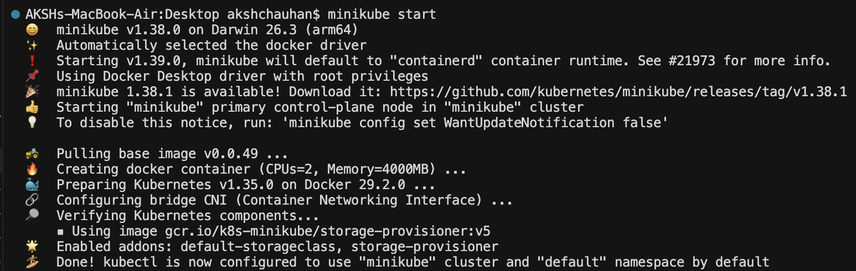

Step 2: Create a ConfigMap from Literal Values

Create a ConfigMap named example-configmap with literal values:
kubectl create configmap example-configmap --from-literal=key1=value1 --from-literal=key2=value2

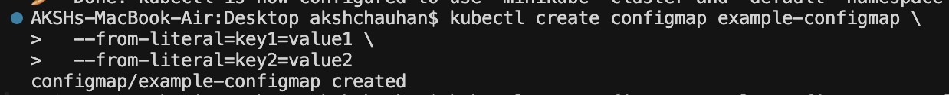

Verify the ConfigMap:
kubectl get configmap example-configmap -o yaml

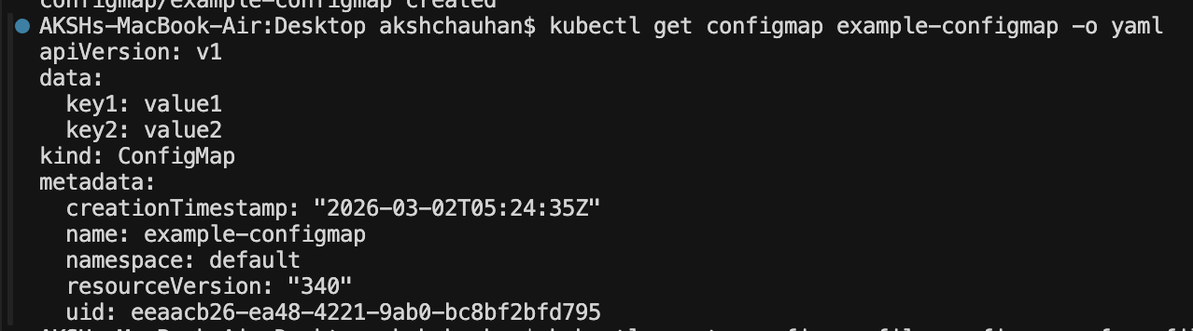
You should see the example-configmap with the keys and values specified.

Step 3: Create a ConfigMap from a File
Create a file named config.txt with the following content:
key1=value1
key2=value2
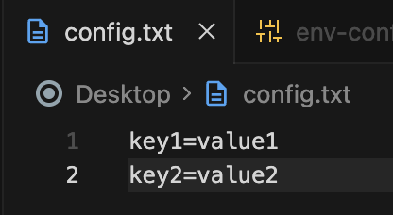
Create a ConfigMap named file-configmap from the file:
kubectl create configmap file-configmap --from-file=config.txt

Verify the ConfigMap:
kubectl get configmap file-configmap -o yaml

You should see the file-configmap with the content of config.txt.
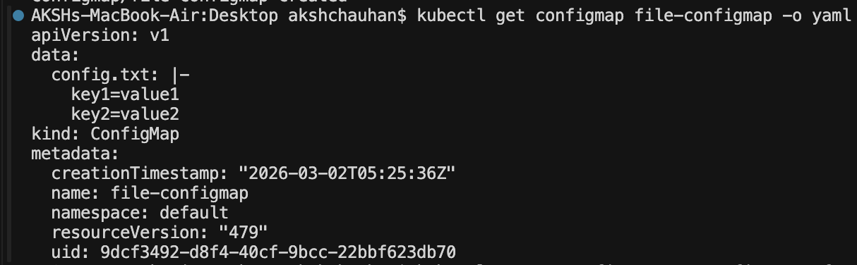

Step 4: Create a ConfigMap from an Environment File
Create an environment file named env-config.env with the following content:
ENV_VAR1=value1
ENV_VAR2=value2
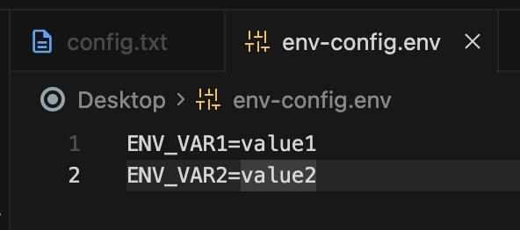

Create a ConfigMap named env-configmap from the environment file:
kubectl create configmap env-configmap --from-env-file=env-config.env

Verify the ConfigMap:
kubectl get configmap env-configmap -o yaml

You should see the env-configmap with the environment variables specified in the file.


Step 5: Create a ConfigMap from Multiple Files
Create multiple files:
config1.txt with content:
key1=value1

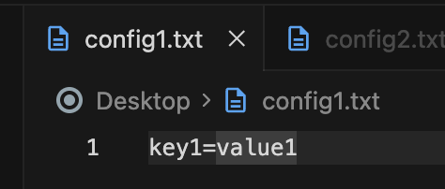
config2.txt with content:
key2=value2

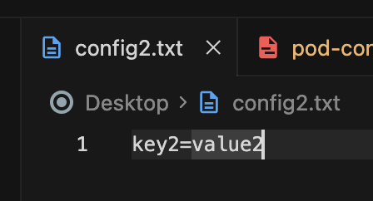
Create a ConfigMap named multi-file-configmap from multiple files:

kubectl create configmap multi-file-configmap --from-file=config1.txt --from-file=config2.txt

Verify the ConfigMap:
kubectl get configmap multi-file-configmap -o yaml

You should see the multi-file-configmap with the content of both config1.txt and config2.txt.
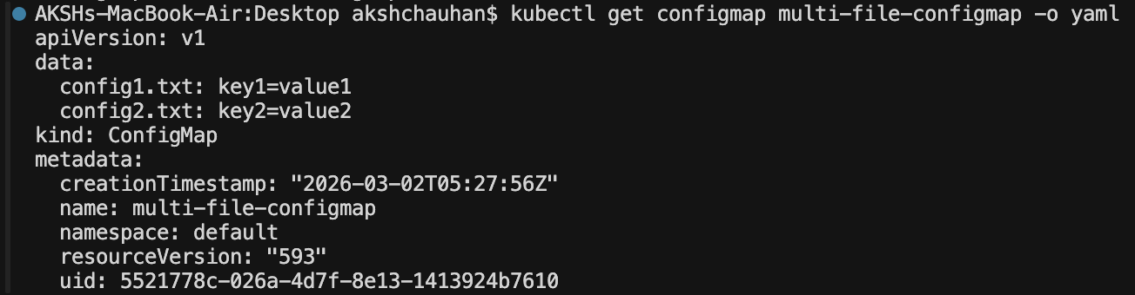

Step 6: Use ConfigMaps in a Pod
Create a file named pod-configmap.yaml with the following content:
apiVersion: v1
kind: Pod
metadata:
name: configmap-pod
spec:
containers:
- name: nginx
image: nginx
envFrom:
- configMapRef:
name: env-configmap

In this manifest:

- The Pod reads environment variables from the env-configmap.
- The Pod mounts the file-configmap at /etc/config.
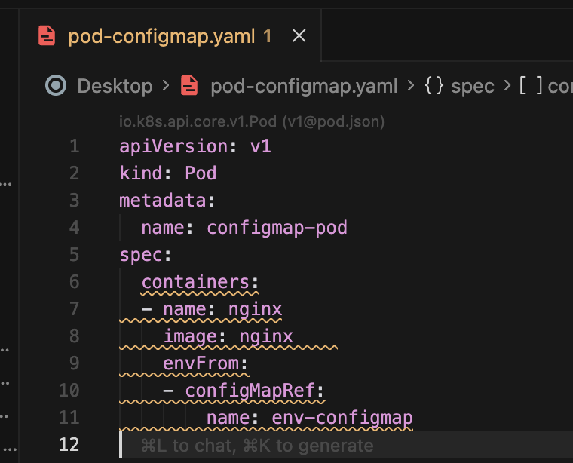

Apply the manifest to create the Pod:

kubectl apply -f pod-configmap.yaml

Check the status of the Pod:
kubectl get pods

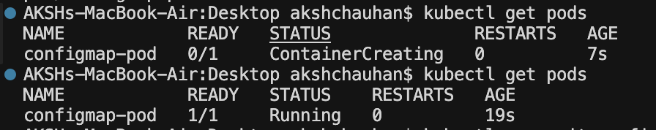
View the Pod logs to see the environment variables and file content:

kubectl exec -it configmap-pod -- printenv

You should see the environment variables and the content of the file-configmap.
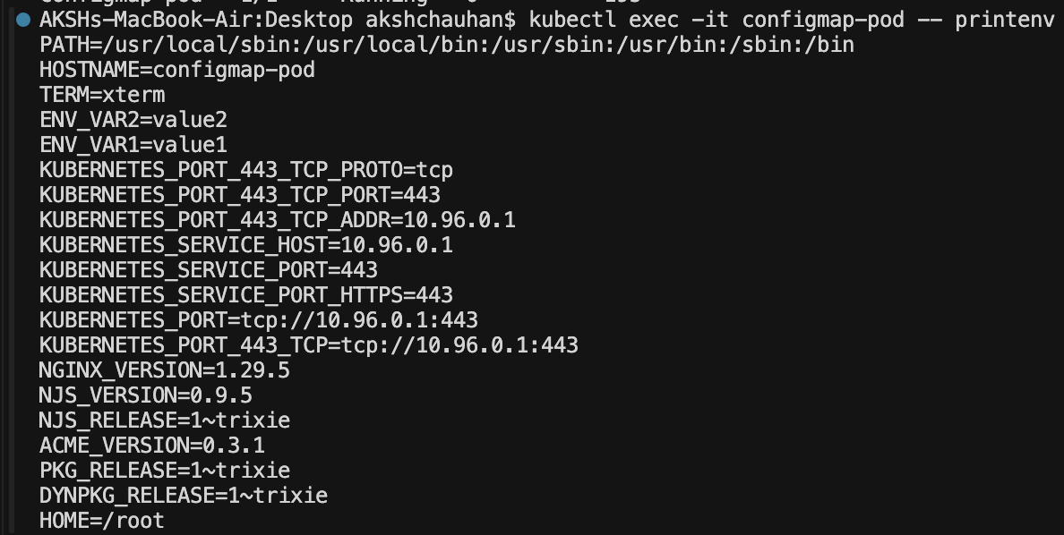

Step 7: Clean Up
After completing the exercise, clean up the resources created:
kubectl delete pod configmap-pod
kubectl delete configmap example-configmap
kubectl delete configmap file-configmap
kubectl delete configmap env-configmap
kubectl delete configmap multi-file-configmap
rm config.txt env-config.env config1.txt config2.txt

